PARTNERSHIP FUND SPOTLIGHT
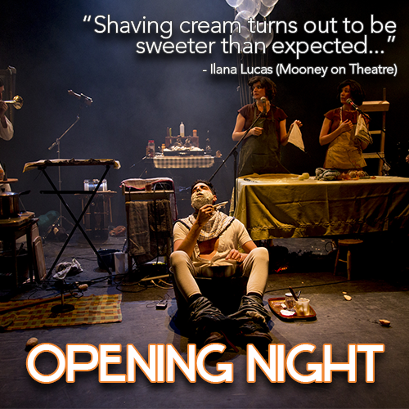
Event: Kick & Push Festival
Partner Organization: Kingston Theatre Alliance
The Kingston Theatre Alliance showcased its fourth annual Kick & Push Festival from July 18th, 2019 to August 11th, 2019. It is a professionally-run three week-long festival that features Canadian performers presenting original, international award-winning work across eight venues in Kingston’s downtown core.

What was the objective of this year’s Partnership Funding project?
2019 was KTA’s most ambitious year to date and included an Indigenous Programming Stream: In partnership with Dora award winning indigenous artist Waawaate Fobister, the K&P engaged two Indigenous companies to present eight performances across downtown Kingston over ten days. KTA also added a Francophone Programming Stream. In partnership with Le Centre Culturel Frontenac which featured five performances of the Francophone production of “Emmac Terre Marine” showcasing the work of the critically acclaimed Emmanuelle Calvé and Richard Desjardins.
71% of core performances were held outside of traditional theatre spaces. These included shows performed in a public library, a moving transit bus, Springer Market Square and Oak Island National Park.
The 2019 Kick & Push provided the culmination of a two-season residency project with Sidemart Theatrical Grocery, in which they developed an immersive experience on an island managed by Parks Canada with Juno award winner Matthew Barber. This experience was called “Out of the Woods.”

Project Rationale and Demand
The Kick & Push Festival is intended to build on the appeal of Kingston to develop cultural experiences that are unique to this community that also acts as a hub between Toronto, Ottawa and Montreal. Recent experience has shown that artists and audiences are willing to travel to Kingston because it is a small, walkable city rich in heritage and leisure activities but also has the resources needed in terms of facilities and talent to offer cultural experiences that differ from other cities of a similar size.

Did you meet the goals you set out in your project?
The Kick & Push Festival 2019 met or exceeded all of our projected performance measures.
The 2019 Festival achieved an overall house size of 68%, with 32%-34% of our audience from outside of Kingston, with 20%-21% of audiences having traveled 100km or more. The 2019 Festival attracted younger audiences, with 59% of audience members under the age of 40, and 42% of audience members between the ages 20 and 29. This data was compiled using box office information, as well as festival staff facilitating electronic surveys at all festival events.
Marketing: By engaging two professional marketing entities, namely Emilie Leneveu, Marketer and Development officer, as well as Alphabet Creative, our 2019 marketing was of a higher grade than ever before.

We exceeded the marketing goals outlined in our communication plan, particularly in regards to our digital and social marketing. The Kick & Push 2019 had two digital campaigns, one managed by Alphabet Creative, the other managed internally.
a) visitkingston.ca – 535,960 impressions 136,481 reach 3923 clicks 11,986 video views
b) Internal Campaign:
Facebook: Total Page Likes: 1,290. Post Total Reach: 37,139. Post Total Impressions: 53,704. Posts: 82. Post likes: 722. Comments: 29. Shares: 110
Twitter: Followers: 869. Tweets: 57. Retweets: 12. Favourites: 69. Impressions: 14,730.
Instagram: Posts: 150. Followers: 514. Following: 370.

Partners are fundamental to our success and we’re not shy in asking. Participating partners for the 2019 season includedL The City of Kingston, RTO 9, Downtown Kingston BIA, Tourism Kingston, Kingston Accommodation Partners, The Grand Theatre, The Whig Standard, Alphabet, 98.9 the Drive, 98.3 Fly FM, Film & Media Studies at Queen’s University, CFRC Campus Radio. Keystone Property Management, Ontario Arts Council, Celebrate Ontario, The Leon’s Centre, The Dan School of Music & Drama, Loyalist College, The Screening Room, Le Centre Culturel Frontenac, Old Farm Fine Foods.

Overall thoughts on your partnership with RTO 9?
RTO 9 partnership funding is what has allowed our small enterprise to develop original, experiential tourism experiences in southeastern Ontario. The fiscal support and expertise so graciously provided mitigated the risks inherent in innovative product development, allowing us to continue to adapt our cultural offerings to suit the ever-evolving marketplace.

